Case Study Report

Data Analytics with Power BI

**“**CROP PRODUCTION

ANALYSIS”

**THANTHAI PERIYAR GOVT ARTS &**

**SCIENCE COLLEGE**

|  |  |
| --- | --- |
| **NM ID** | **NAME** |
|  |  |

|  |  |
| --- | --- |
|  |  |
|  | Trainer Name |
|  | Master Trainer |

**ABSTRACT**

Crop production analysis is crucial for understanding agricultural trends, optimizing resources,and enhancing productivity. Leveraging Power BI, a robust business intelligence tool, offers a comprehensive platform for visualizing and analyzing crop production data. This study aims to demonstrate the utilization of Power BI for crop production analysis by integrating various data sources such as historical yield data, weather patterns, soil quality, and crop management practices.Through interactive dashboards and intuitive visualizations, stakeholders can gain insights into crop performance, identify patterns, and make informed decisions to improve agricultural practices. The analysis encompasses factors affecting crop yield, seasonality, regional variations, and the impact of external factors like climate change. Additionally, predictive modeling techniques can be employed to forecast future yields based on historical data and external variables.

**INDEX**

|  |  |  |
| --- | --- | --- |
| **Sr. No.** | **Table of Contents** | **Page No.** |
| 1 | Chapter 1: Introduction | 4 |
| 2 | Chapter 2: Data Collections | 6 |
| 3 | Chapter 3: Project Architecture | 7 |
| 4 | Chapter 4: Modeling and Result | 10 |
| 5 | Conclusion | 13 |
| 6 | Future Scope | 14 |
| 7 | References | 15 |
| 8 | Links | 16 |

**CHAPTER 1**

**INTRODUCTION**

Crop production is the cornerstone of global agriculture, serving as the primary source of food,feed, fiber, and fuel for billions of people around the world. It encompasses the cultivation of a diverse range of crops, including grains, vegetables, fruits, oil seeds, and pulses, in various agroecological settings and climates.

The process of crop production involves a series of interconnected activities, including land preparation, planting, cultivation, irrigation, fertilization, pest and disease management, harvesting, and post-harvest handling. Each stage requires careful planning, management, and monitoring to optimize yields, minimize losses, and conserve resources.

* 1. **Feature :**
* **Crop Diversity:** Crop production encompasses a wide variety of crops, including grains (such as wheat, rice, and maize), pulses (such as lentils and chickpeas), oilseeds (such as soybeans and sunflower), fruits, vegetables, and fibers.
* **Agroecological Adaptation:** Different crops thrive in specific agroecological conditions, including soil types, temperature ranges, precipitation levels, and elevation.
* **Seasonality:** Many crops are grown seasonally, with planting and harvesting occurring at specific times of the year based on climatic conditions and crop life cycles. Seasonality affects production schedules, labor requirements, and market supply dynamics.
  1. **Advantages :**
* **Food Security :** Crop production ensures a stable and sufficient food supply to meet the nutritional needs of a growing global population.
* **Economic Stability :** Crop production serves as a key driver of economic growth, providing income and employment opportunities for millions of people worldwide.
* **Climate Change Adaptation :** Crop production practices can help mitigate and adapt to climate change by promoting climate-smart agriculture techniques. Drought-tolerant crops, resilient varieties, water-efficient irrigation systems, and carbon sequestration practices contribute to climate resilience and sustainable food production.

**CHAPTER 2**

**DATA COLLECTIONS**

**2.1 Data Collections :**

* **Crop Acreage and Planting Data:** Collecting data on the acreage of land dedicated to different crops is essential for understanding cropping patterns and trends. This information includes the type of crop planted, planting dates, planting density, and planting methods (e.g., direct seeding or transplanting). Farmers may maintain records of their planting activities, or this data may be collected through agricultural surveys conducted by government agencies or agricultural organizations.
* **Crop Growth and Development:** Monitoring crop growth and development throughout the growing season provides insights into crop health, phenological stages, and growth rates. This data can be collected through field observations, remote sensing technologies (such as satellite imagery or drones), or crop monitoring apps. Parameters such as canopy cover, leaf color, and biomass accumulation can indicate the health and vigor of crops.
* **Weather and Climate Data:** Weather and climate data are critical for understanding the environmental conditions that influence crop growth and development. Data collection may involve accessing historical weather records from weather stations, monitoring current weather conditions using weather sensors or apps, or using climate models to forecast future weather patterns. Key weather variables include temperature, rainfall, humidity, wind speed, solar radiation, and evapotranspiration rates.

**CHAPTER 3**

**PROJECT ARCHITECTURE**

**3.1 Architecture**

*High-Level Architecture for Crop Production Project :*

1. **Data Sources :**

* **Agricultural Surveys :** Data collected through field surveys, interviews, and questionnaires conducted with farmers to gather information on crop types, planting practices, and management strategies.
* **Remote Sensing Technologies:** Satellite imagery, drones, and aerial photography provide data on crop growth, health, and environmental conditions.
* **Weather Stations :** Collect weather data including temperature, precipitation, humidity, and wind speed to assess climate impacts on crop production.
* **Soil Testing Labs :** Obtain soil data on fertility, nutrient levels, pH, and texture to inform soil management practices.
* **Market Surveys and Price Databases :** Gather market data on crop prices, demand, supply, and trade volumes.

1. **Data Integration :**

* Data from diverse sources are integrated into a central repository or data lake using ETL (Extract, Transform, Load) processes.
* Data integration may involve cleaning, standardizing, and harmonizing data formats and structures to ensure consistency and compatibility.

1. **Data Storage :**

* The integrated data is stored in a data warehouse or data lake for easy access, retrieval, and analysis.
* Cloud-based storage solutions like Amazon S3, Google Cloud Storage, or Azure Blob Storage are commonly used for scalability and flexibility.

1. **Data Processing and Analysis :**

* Analytical tools and frameworks such as Apache Spark, Hadoop, or Databricks are employed for processing and analyzing large datasets.
* Machine learning algorithms and statistical techniques are applied to derive insights, identify patterns, and make predictions related to crop production.

1. **Visualization and Reporting :**

* Visualization tools like Power BI, Tableau, or matplotlib are utilized to create interactive dashboards, charts, and reports for stakeholders.
* Visualizations provide insights into crop performance, market trends, weather impacts, and other relevant metrics, facilitating data-driven decision-making.

1. **Predictive Modeling and Forecasting :**

* Predictive models are developed to forecast crop yields, identify risk factors, and optimize management practices.
* Machine learning algorithms such as regression, classification, and time series analysis are employed for predictive modeling.

1. **Deployment and Monitoring :**

* The crop production analysis system is deployed either on-premises or on cloud platforms like AWS, Azure, or Google Cloud.
* Continuous monitoring and evaluation ensure the reliability, performance, and accuracy of the system, with alerts for anomalies or issues.

1. **Integration with Decision Support Systems :**

* The insights generated from crop production analysis are integrated into decision support systems used by farmers, agronomists, policymakers, and other stakeholders.
* Decision support systems provide actionable recommendations and guidance to optimize crop management practices, mitigate risks, and enhance productivity.

1. **Feedback Loop :**

* A feedback loop is established to incorporate insights from real-world outcomes back into the system, improving the accuracy and relevance of future analyses and predictions.

By following this high-level architecture, the crop production project can effectively leverage data-driven approaches to optimize agricultural practices, improve yields, and ensure sustainable crop production.

**CHAPTER 4**

**MODELING AND RESULT**

**Manage Relationship :**

In crop production, managing relationships encompasses interactions and collaborations among various stakeholders involved in the agricultural value chain. These relationships are essential for optimizing production, addressing challenges, and ensuring sustainability.

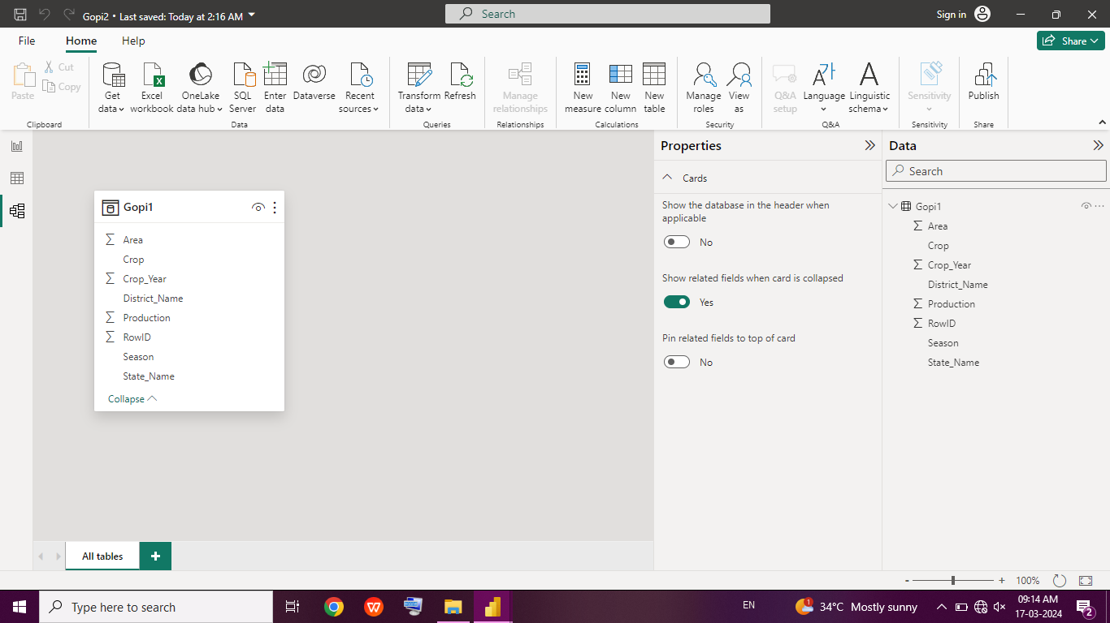

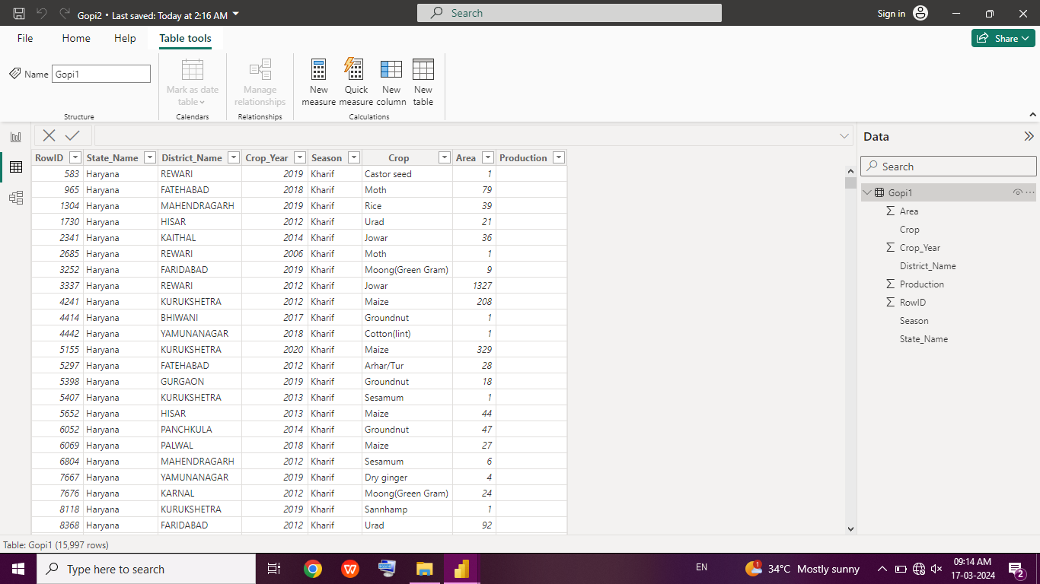

**Changed Type :**

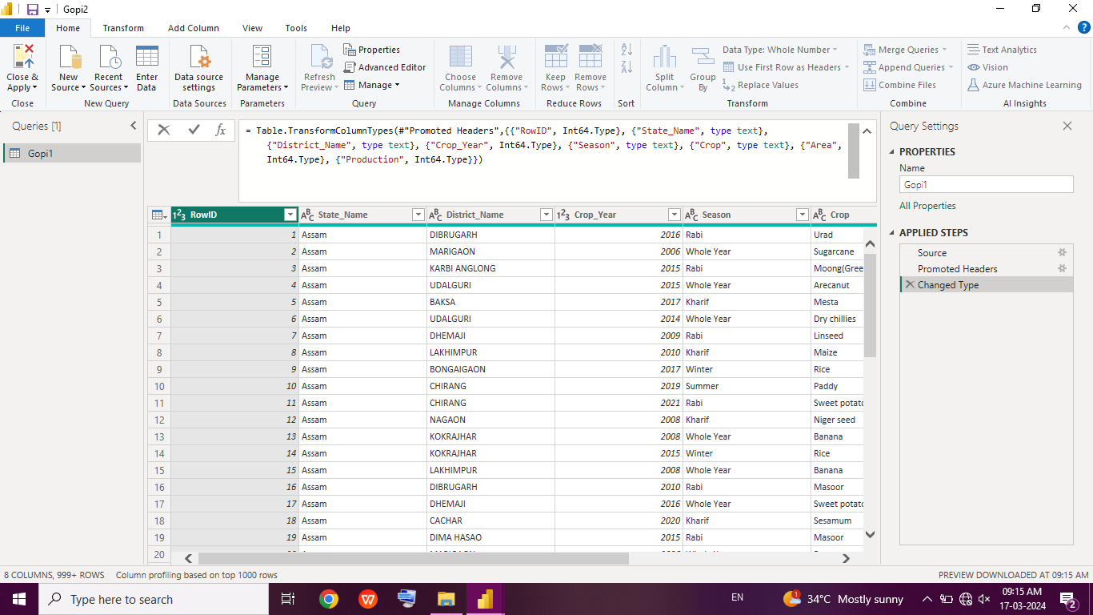

**Promoted Headers :**

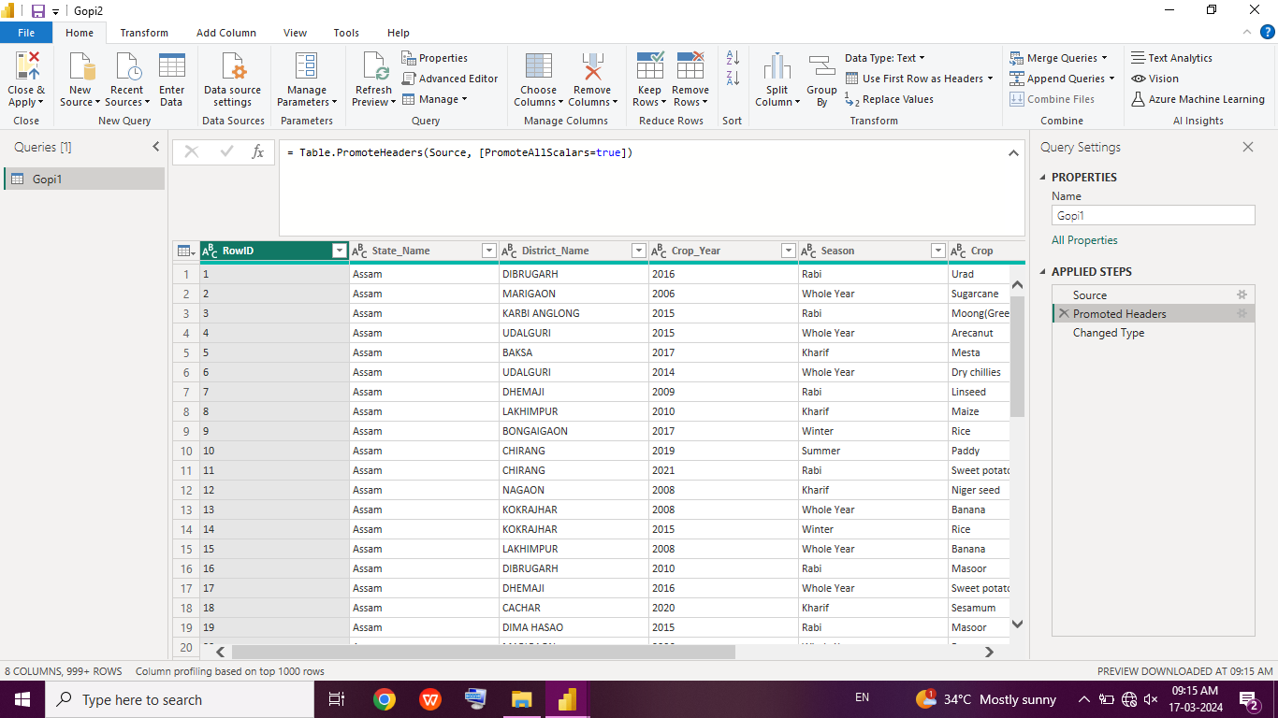

**Dashboard :**

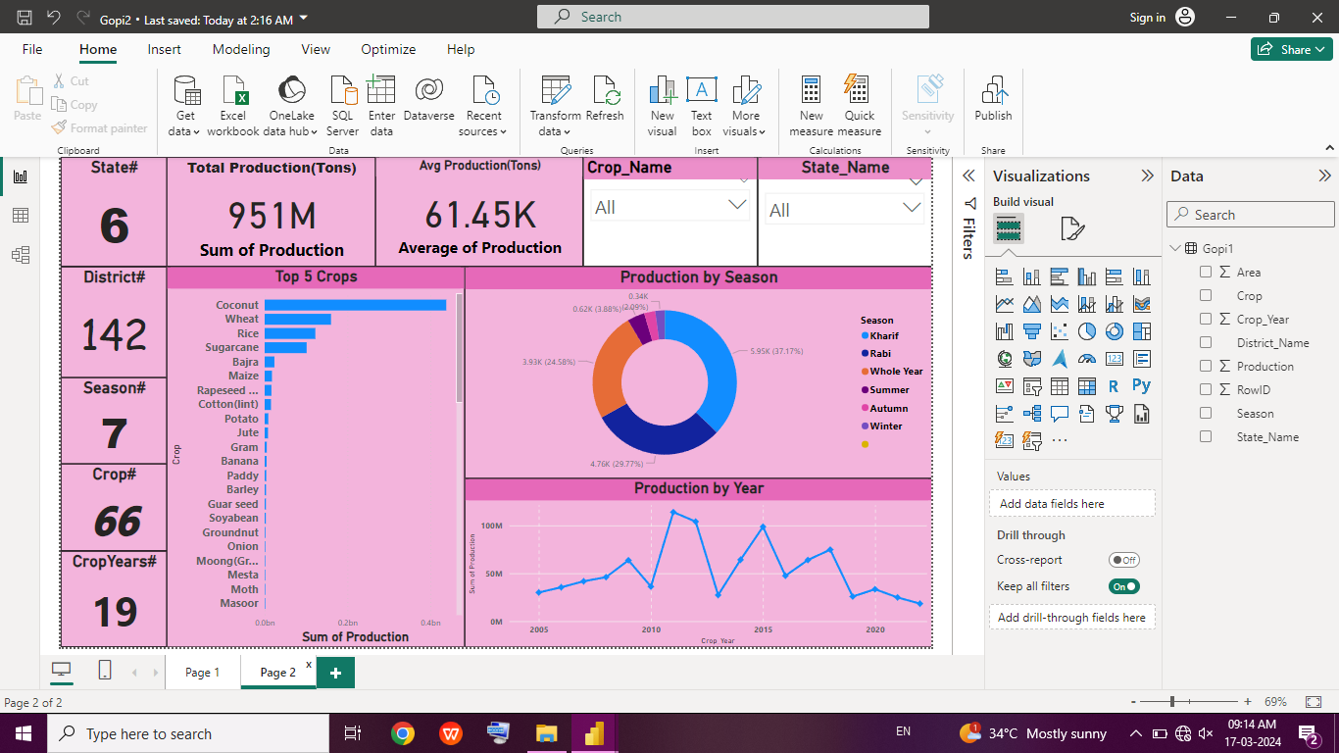

**CONCLUSION**

In conclusion, crop production analysis stands as a pivotal tool in modern agriculture, offering invaluable insights into optimizing productivity, sustainability, and resilience in crop production systems. Throughout this exploration, we have delved into the significance, methodologies, and future prospects of crop production analysis.

**FUTURE SCOPE**

In summary, the future of crop production holds immense promise for innovation, sustainability, and resilience in agriculture. By embracing emerging technologies, adopting climate-smart practices, and prioritizing environmental stewardship and consumer preferences, we can shape a future where crop production is not only productive and profitable but also equitable, resilient, and environmentally sustainable.

**REFERENCES**

**LINK**